**CHAPTER 10**

10.43: (a) P(20 years old or older) = 1 – 0.171 = 0.829 (or sum the entries in the second, third and fourth columns). (b) P(does not live alone) = 1 – P(lives alone) = 1 – 0.073 = 0.927.

10.44: (a) X is discrete, because it has a finite sample space. (b) “At least one nonword error” is the event {X ≥ 1} (or {X > 0}). P(X ≥ 1) = 1 − P(X = 0) = 0.9. (c) {X ≤ 2} is “no more than two nonword errors,” or “fewer than three nonword errors.” P(X ≤ 2) = P(X = 0) + P(X = 1) + P(X = 2) = 0.1 + 0.2 + 0.3 = 0.6. P(X < 2) = P(X = 0) + P(X = 1) = 0.1 + 0.2 = 0.3.

**CHAPTER 12**

12.12: (a) There are a total of 976 professors, of which 272 are women, so P(woman) = 272/976 = 0.2787. (b) P (woman | full professor) = 73/375 = 0.1947. (c) Rank and sex are not independent; if they were, the probabilities in (a) and (b) would be equal.

12.14: (a) The tree diagram follows. (b) P(positive) = 0.009985 + 0.00594 = 0.015925.

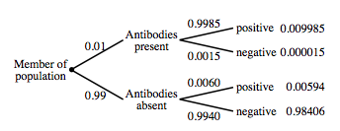

12.31: PLAN: Let I be the event “infection occurs” and let F be “the repair fails.” We have been given P(I) = 0.03, P(F) = 0.14, and P(I and F) = 0.01. We want to find P(not I and not F). SOLVE: First use the general addition rule: P(I or F) = P(I) + P(F) − P(I and F) = 0.03 + 0.14 − 0.01 = 0.16. This is the shaded region in the Venn diagram provided. Now observe that the desired probability is the complement of “I or F” (the unshaded region): P(not I and not F) = 1 − P(I or F) = 0.84. CONCLUDE: 84% of operations succeed and are free from infection.

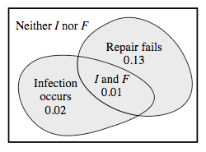

12.33: PLAN: Let I be the event “infection occurs” and let F be “the repair fails.” Refer to the Venn diagram in Exercise 12.31 (ignoring the shading). We want to find P(I | not F). SOLVE: We have P(I | not F) = P(I and not F)**/**P(not F) = 0.02**/**0.86 = 0.0233. CONCLUDE: The probability of infection given that the repair is successful is 0.0233. That is, in 2.33% of all successful operation cases, the patient develops infection.